To Validate Email Addresses Using Lex Program

AIM:
To write a Lex program to identify and display valid email addresses from an input file.
PSEUDOCODE:

- Start.
- Read the input filename from the command-line argument.
- Open the input file and check whether it opens successfully.
- Set the file as the Lex input source.
- Scan the file for valid email addresses using the given pattern.
- Display each valid email address found.
- Close the file.
- Stop.

Program:

%{
#include <stdio.h>
%}

%%
[A-Za-z0-9._%+-]+@[A-Za-z0-9.-]+\.[A-Za-z]{2,} {
printf("Valid Email: %s\n", yytext);
}
.|\n ;
%%

int yywrap(void)
{
return 1;
}

int main(int argc, char *argv[])
{
if (argc != 2)
{
printf("Usage: %s input.txt\n", argv[0]);
return 1;
}

FILE *fp = fopen(argv[1], "r");

if (fp == NULL)
{
printf("Error opening file!\n");
return 1;
}

yyin = fp;
yylex();

fclose(fp);
return 0;
}

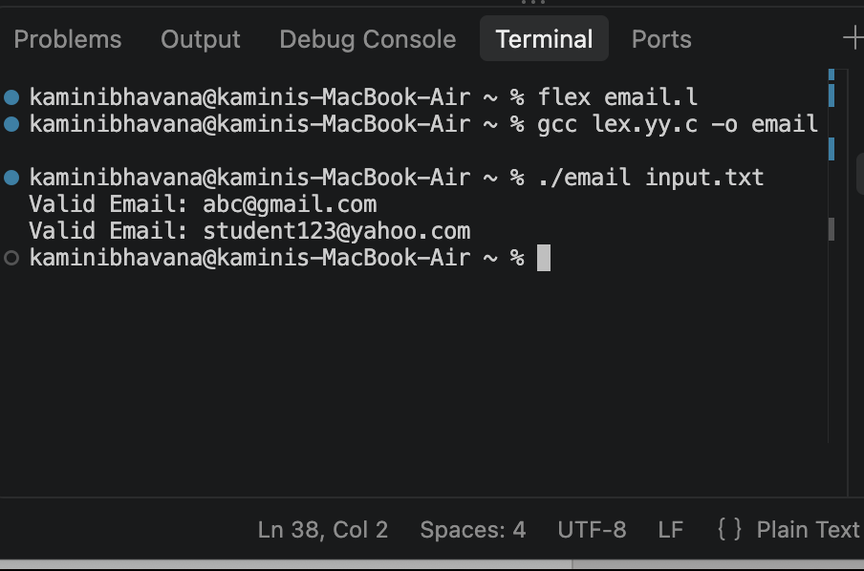
OUTPUT:

